# References used in mouse game

* <https://www.freepik.com/free-vector/cute-mouse-holding-cheese-cartoon-illustration-animal-food-concept-isolated-flat-cartoon_11189735.htm#query=mouse%20cheese&position=16&from_view=keyword&track=ais&uuid=eae4a4b0-955c-46eb-8149-bcaf5623c1fc>
* 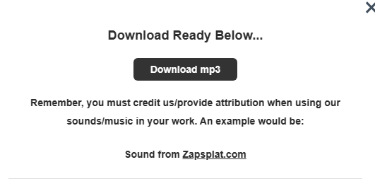  
  Mouse Sound
* Trash Sound:  
  <https://pixabay.com/service/license-summary/>
* Fonts:
  + Dinomouse